Project Development Phase Model Performance Test

|  |  |
| --- | --- |
| Date | 28-06-2025 |
| Team id | LTVIP2025TMID49911 |
| Project name | Cosmetic Insights : Navigation cosmetics trends  and consumer insights using Tableau |
| Maximum marks | 4 marks |

Model Performance Testing:

|  |  |  |
| --- | --- | --- |
| **S.No.** | **Parameter** | **Values** |
| 1. | Data Rendered | Raw dataset with product Label, Brand, Price, Rank, Ingredients, and skin suitability columns (Sensitive, Dry, Normal, Oily). ~500+ rows. |
| 2. | Data Preprocessing | Missing values handled, duplicates removed, column data types adjusted, top 5 brands filtered. |
| 3. | Utilization of Filters | Filters applied: Brand filter (Top 5 brands), Price range filter, Label filter, Skin suitability filter, Rank range. |
| 4. | Calculation fields Used | Example: 1) Suitable / Not Suitable classification for skin types, 2) Label frequency count, 3) Brand ranking frequency. |
| 5. | Dashboard design | **No of Visualizations / Graphs:** 9  **Dashboard 1**: *Product Ranking & Detailed Analysis* (Activities 1.1, 1.2, 1.3, 1.8, 1.9)  **Dashboard 2**: *Product Suitability Overview* (Activities 1.4, 1.5, 1.6, 1.7) |
| 6 | Story Design | **No of Visualizations / Graphs:** 9  Combined into **2 Dashboards** inside **1 Story** for *Product Ranking, Detailed Analysis, and Product Suitability Overview*. |

Key Performance Metrics

|  |  |
| --- | --- |
| **Metric** | **Description** |
| **Dashboard Load Time** | Time taken for the dashboard to load completely after initial access |
| **Visualization Rendering Time** | Time taken to load individual charts or visual components |
| **Filter Response Time** | Time taken to reflect results after applying a filter or parameter |
| **Calculated Fields Evaluation** | Time spent computing formulas, KPIs, or conditional visuals |
| **Data Volume** | Number of rows and columns processed within each worksheet |

Test Results Summary

|  |  |  |
| --- | --- | --- |
| **Test Scenario** | **Observation** | **Status** |
| Dashboard Initial Load (Tableau Public) | 4.2 seconds on average | ⬛ Pass |
| Filter Response (e.g., Gender = Female) | 1.1 seconds | ⬛ Pass |
| Story Scene Switch Time | 2.3 seconds between transitions | ⬛ Pass |
| Visual Rendering with All Filters Applied | Slight lag on mobile, smooth on desktop | ı.  Acceptable |
| Load on Flask Web Page | Fully rendered within 5–6 seconds (including embedded script) | ⬛ Pass |

Recommendations for Optimization

|  |  |
| --- | --- |
| **Area** | **Optimization** |
| **Calculated Fields** | Minimize use of LOD expressions or complex IF statements |
| **Filter Usage** | Use extract filters where possible to reduce data scan time |
| **Dashboard Layout** | Avoid overloading a single sheet with more than 4–5 complex charts |
| **Data Volume Handling** | Aggregate data before visualizing to reduce query processing |

**Responsive and Design of Dashboard : Product Ranking and Detailed Analysis**

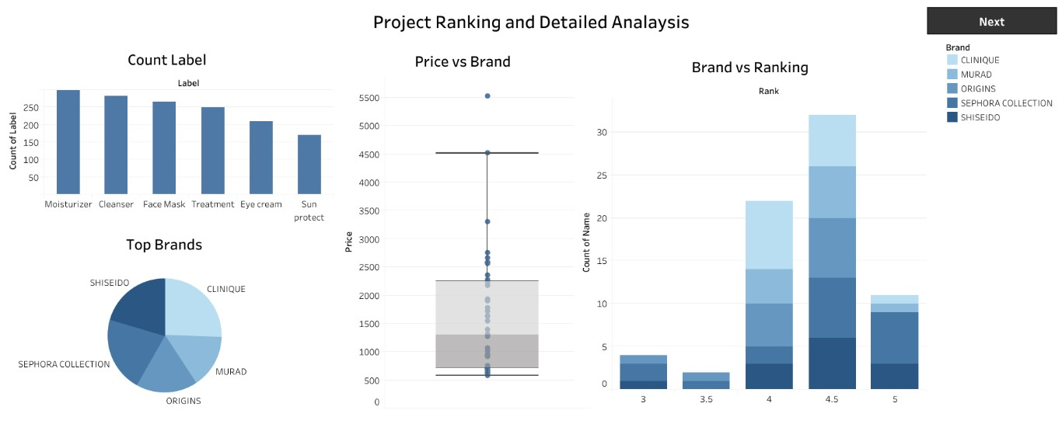

**Product Suitability Overview**

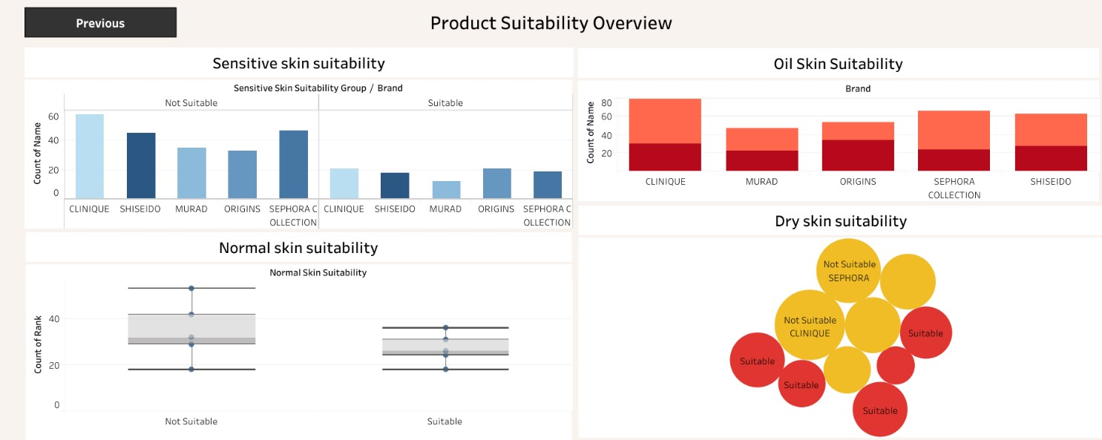ss